**SPRINT:2**

|  |  |
| --- | --- |
| DATE | 12 November 2022 |
| TEAM ID | PNT2022TMID34135 |
| PROJECT NAME | IoT based smart crop protection system for agriculture |
| MAXIMUM MARKS | 20 Marks |

IBM Watson IoT platform acts as the mediator to connect the web application to IoT devices, so create the IBM Watson IoT platform:

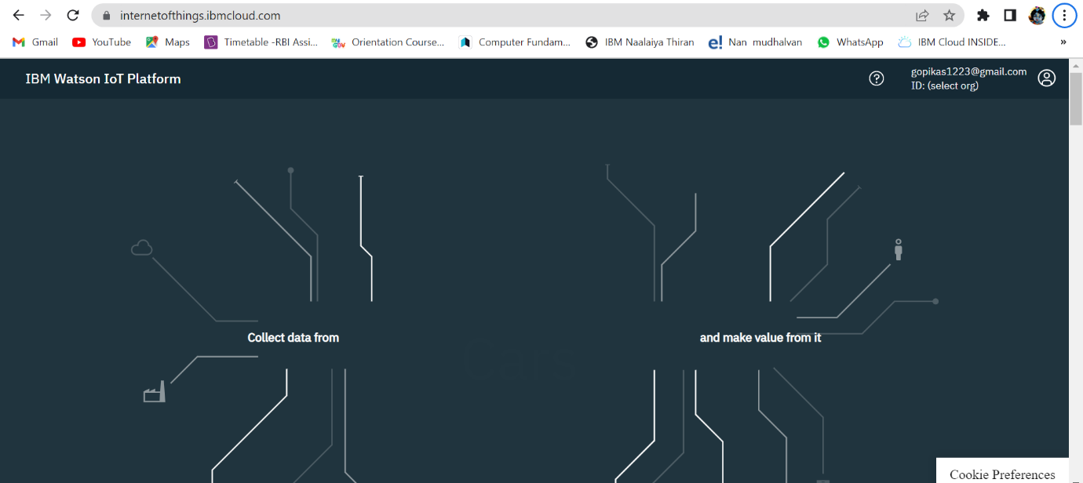

# In order to connect the IoT device to the IBM cloud, create a device in the IBM Watson IoT platform and get the device credentials:

# 

# 

# 

# 

# 